Production-Ready 3-Tier Infrastructure Deployment Using Terraform Modules
Project 3- AWS Internship
Fortune Cloud Technologies
Prepared by: Aaliya Shaikh
Role: AWS Intern
Tools Used: AWS,VS code
Github Link: https://github.com/AaliyaShaikh23/terraform-3tieraws.git

Introduction
In modern cloud environments, manual infrastructure provisioning leads to inconsistencies and errors. To solve this, Infrastructure as Code (IaC) tools like Terraform are used. This project demonstrates a production-ready 3-tier architecture using modular Terraform code, ensuring scalability, security, and reusability.

🟣 Objectives
- Deploy a secure 3-tier architecture on AWS
- Use Terraform modules for reusable infrastructure
- Separate web, application, and database layers
- Implement best security practices
- Automate infrastructure provisioning

🟣 System Architecture Overview
The architecture is divided into three layers:
🔹 Web Tier (Public Subnet)
- Hosted on EC2 instance
- Runs Nginx server
- Displays HTML registration form
- Accessible via internet
🔹 Application Tier (Private Subnet)
- Hosted on EC2 instance
- Runs PHP backend (submit.php)
- Processes form data
- No public IP (secure)
🔹 Database Tier (Private Subnet)
- Amazon RDS (MySQL)
- Stores user data
- Accessible only from application tier

🟣 Detailed Architecture Components
1️⃣ Networking Layer
- Custom VPC
- Public Subnets (Web Tier)
- Private Subnets (App + DB Tier)
- Internet Gateway (IGW)
- NAT Gateway
- Route Tables

2️⃣ Web Tier
- EC2 in public subnet
- Nginx installed via user_data
- HTML registration form deployed
- Allows HTTP/HTTPS traffic

3️⃣ Application Tier
- EC2 in private subnet
- No public IP
- PHP backend handles form submission
- Communicates with RDS

4️⃣ Database Tier
- Amazon RDS (MySQL)
- DB subnet group configured
- Access restricted to app-tier security group

🟣 Terraform Modules
🔹 VPC Module
- Creates VPC, subnets, IGW, NAT
- Handles routing configuration
🔹 EC2 Module
- Launches web and app instances
- Uses user_data for provisioning
🔹 RDS Module
- Creates MySQL database
- Configures subnet group
- Secures database access

🟣 Security Implementation
- Web tier allows only HTTP/HTTPS
- App tier has no public access
- Database accessible only from app tier
- Security groups enforce restricted communication
- Private subnets used for sensitive components

🟣 Architecture Diagram
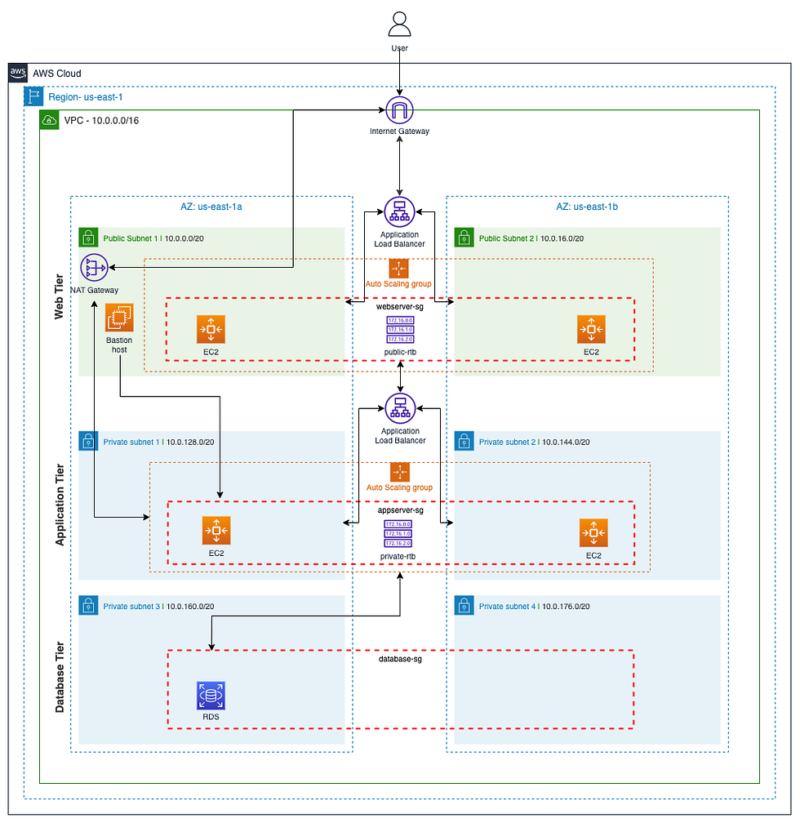

🟣 Deployment Steps
terraform init
terraform plan
terraform apply
Then access:
http://<web-public-ip>

🟣 Results
- Successfully deployed 3-tier architecture
- Website accessible via public IP
- Form submission processed by backend
- Data stored securely in RDS

🟣 Advantages
- Scalable architecture
- Improved security
- Automated deployment
- Reusable Terraform modules
- Reduced manual errors

🟣 Screen Shots
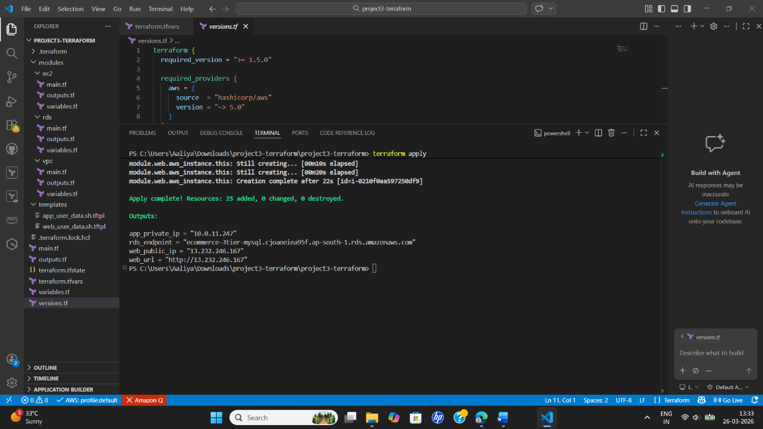

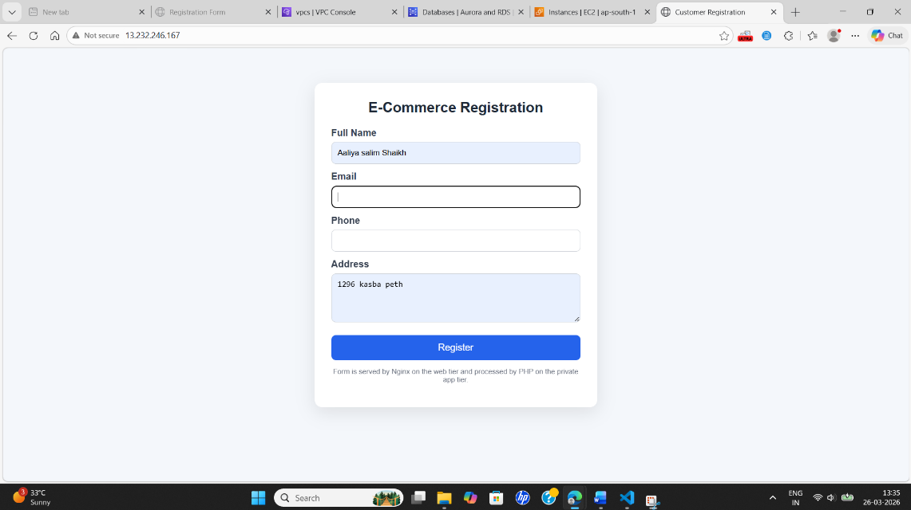

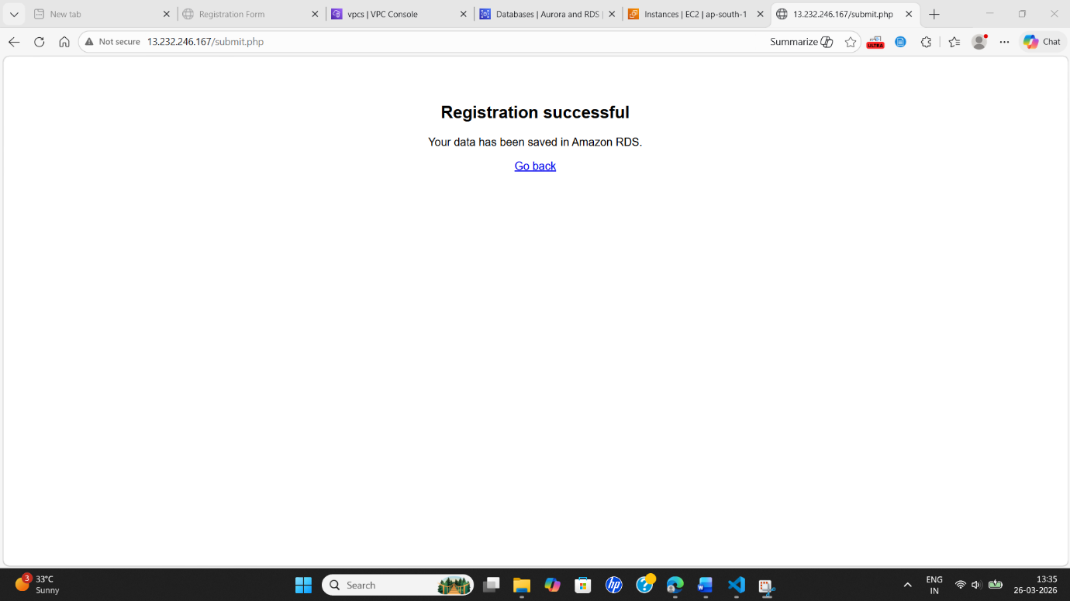

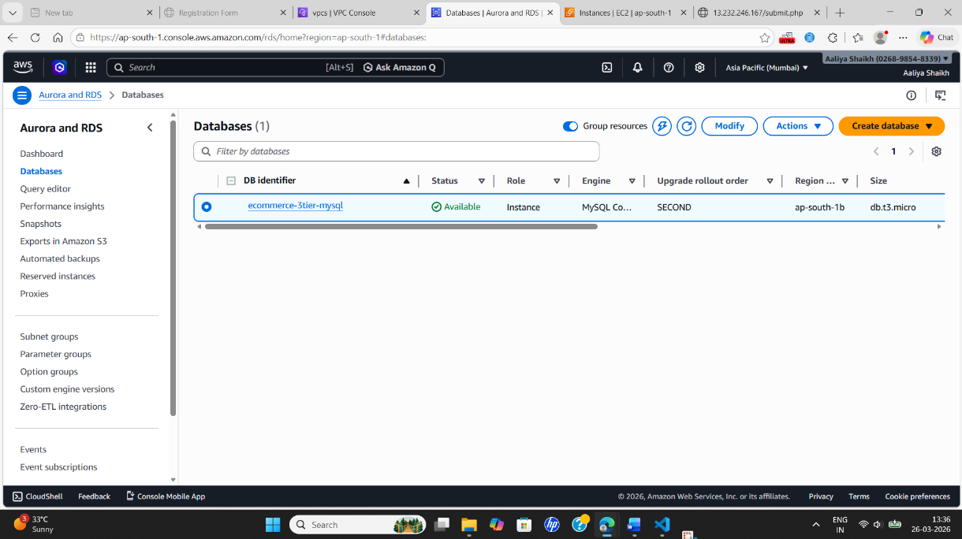

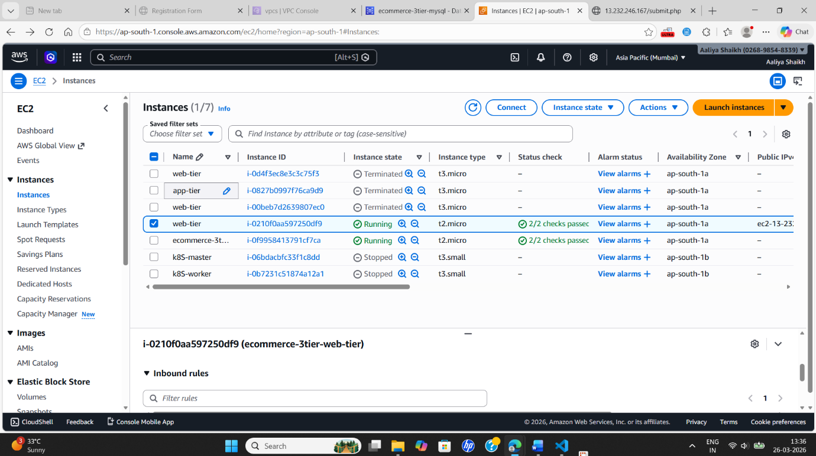

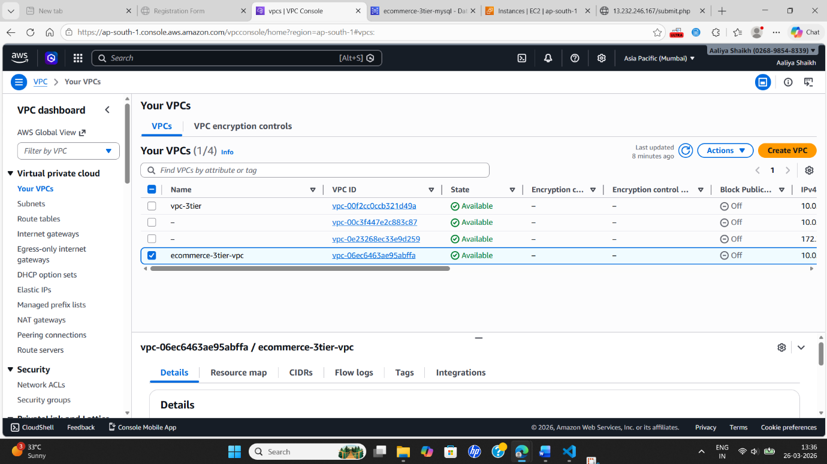

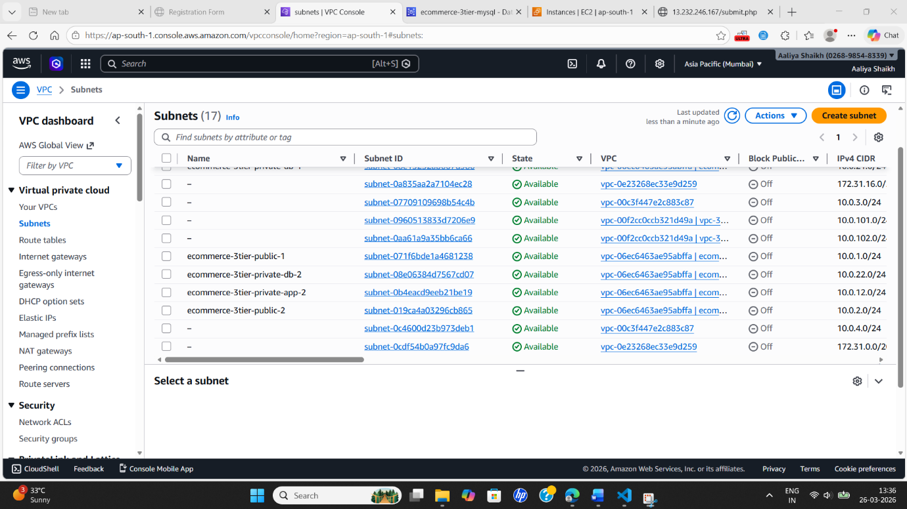

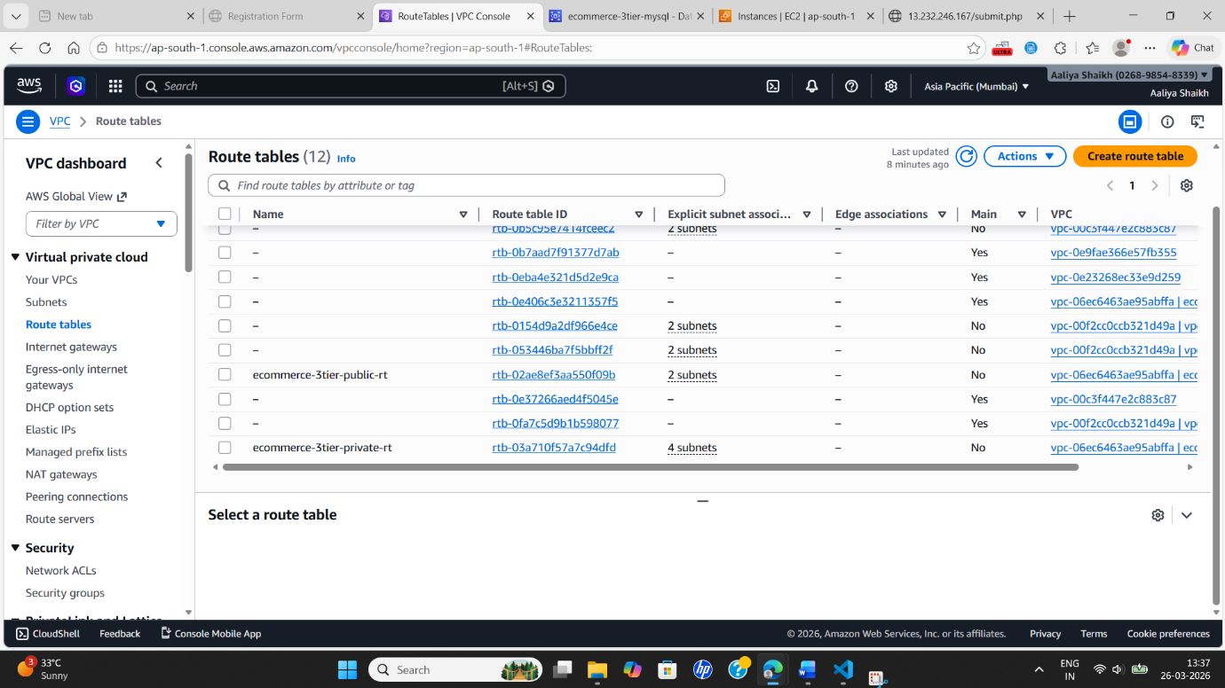

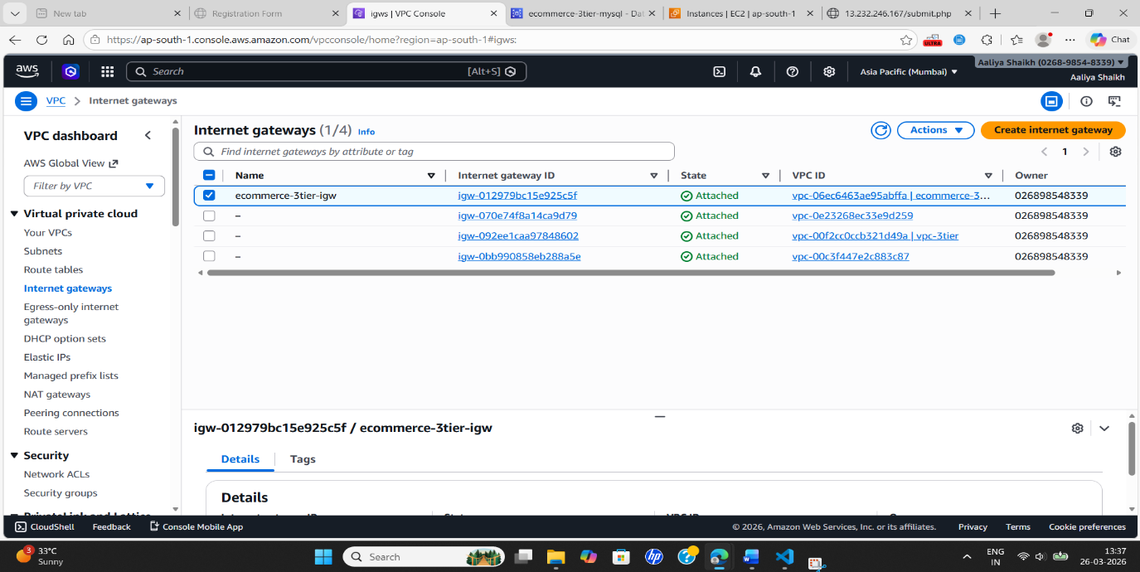

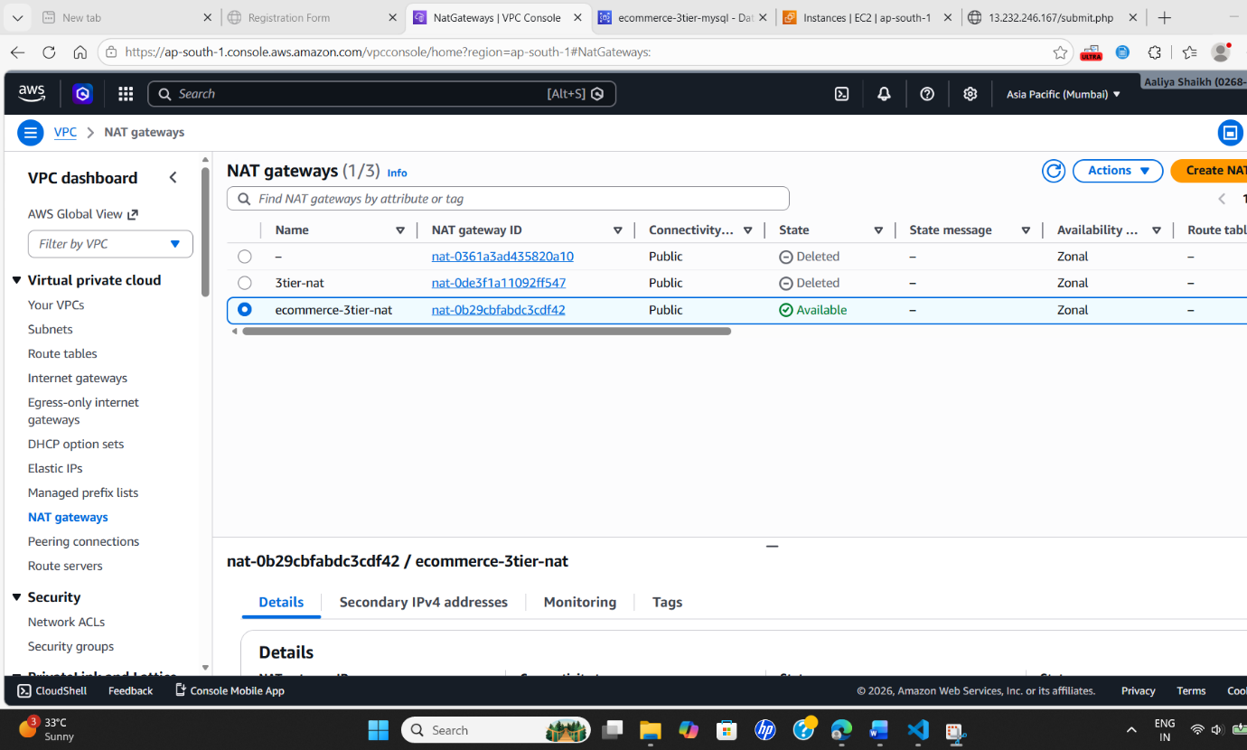
🟣 Conclusion
The project demonstrates a production-ready 3-tier architecture using Terraform. It ensures secure communication between layers and promotes best practices in cloud infrastructure deployment. The use of modules makes the solution reusable and maintainable.

